This may not work for everyone, but it worked for me. I just wanted to share if someone wanted to try a different study method. A lot of this may seem like overkill, but I’ve noticed that it improved my grades. Some may think it’s too time consuming, but I still found it possible to use this study method while worrying about 4 other midterms that same week.

How to Study for Doctor Hays’ Multiple Choice & Essay Questions

If you are pressed for time, just do step 3 and practice your cards.

- Watch lecture for the first time and just listen.
  - I usually listen and crochet at the same time. This is just for casual exposure to the information.
- Watch lecture again and take notes on the PowerPoint slides provided.
  - This is more serious listening and I don’t rewrite the slides. I just write what I feel is missing from the text of the slide (there usually isn’t much missing) or I write a clarification for something (usually it’s something that I hear from the professor).
- Watch lecture a third time and make flashcards as you listen.
  - Write your flashcards out by hand.
    - I hate handwriting everything and usually type when I can. However, I’ve noticed that it is good practice having to write out information for the test and it helps me remember it better and understand the placement of things on the slides. Writing the question and answer is a good form of output.
  - More details on how to write the cards and practice with them are below.
- Watch lecture again the day before the exam or if you’re really struggling with the flashcards.
  - This may clarify information for you or reinforce it.

Making Flashcards
- I use 3” x 2.5” cards since I make a whole ton of cards and want to save paper
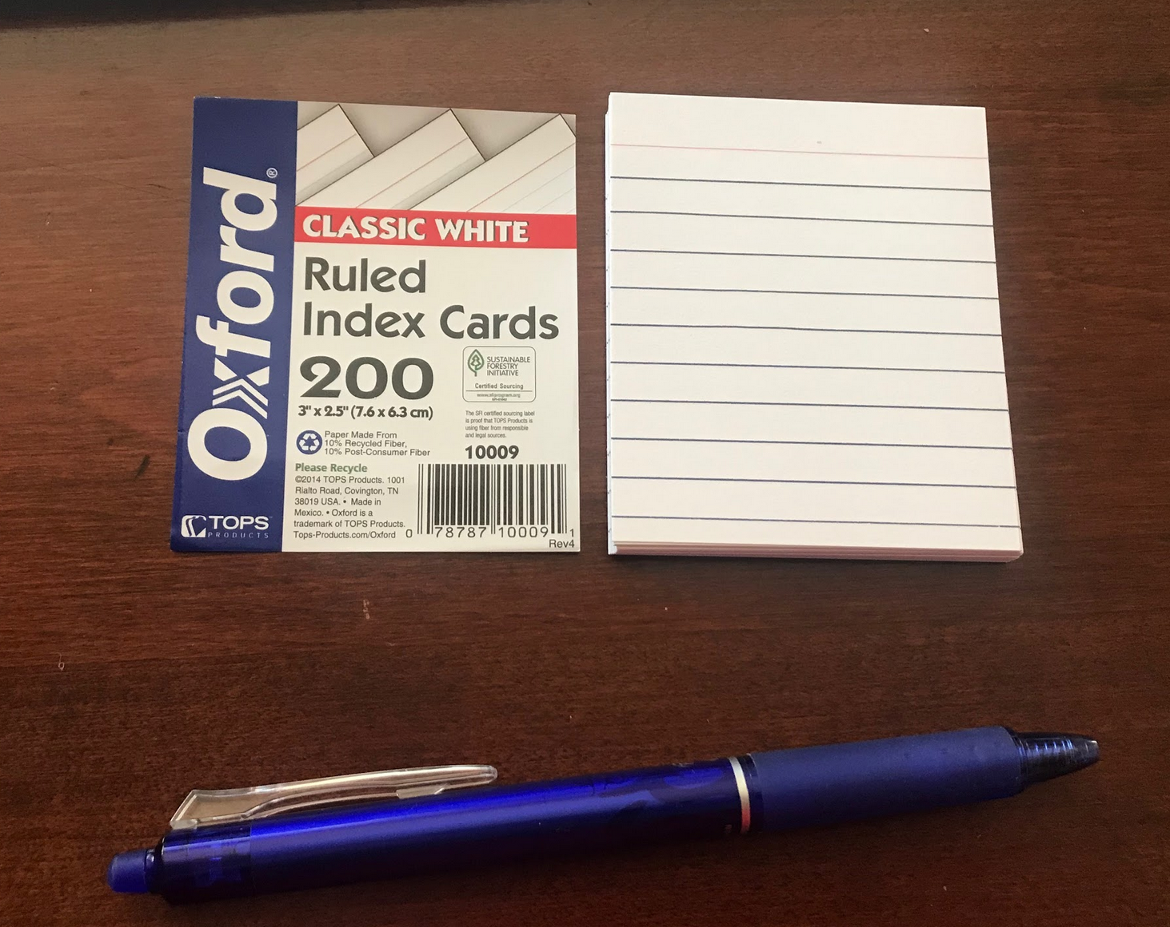
- The questions are always on the lined side
  - They don’t have to phrased in full sentences; just in a way that you can understand and answer
- The answers are always on the blank side
- If you want to go backwards and forwards with information, make another question card instead of studying the cards from front to back and back to front
  - I feel that just causes confusion because the back to front route won’t apply very well to all cards.
  - Example: Make two separate cards to ask about tyrosine:
    - Question: Tyrosine is used to make? Answer: Amine hormones
    - Question: Amine hormones are derived from? Answer: Tyrosine
- Before you move onto another slide while making flashcards, make sure that you’ve asked all the questions that you could’ve asked with your flashcards
  - One slide can end up with tons of flashcards while others might only have a few
  - Make sure to ask questions in multiple ways
- The slides with steps or drawings are made into flashcards too.
  - Answers would not be included on the back (unless you can write/draw small enough); I just referred to the slide/notes every time I needed the answer
Here are examples of how I would make flashcards.

NORMAL SLIDE WITH INFO
Example Slide | Question/s I Would Write (Each question gets one flashcard) | Answer
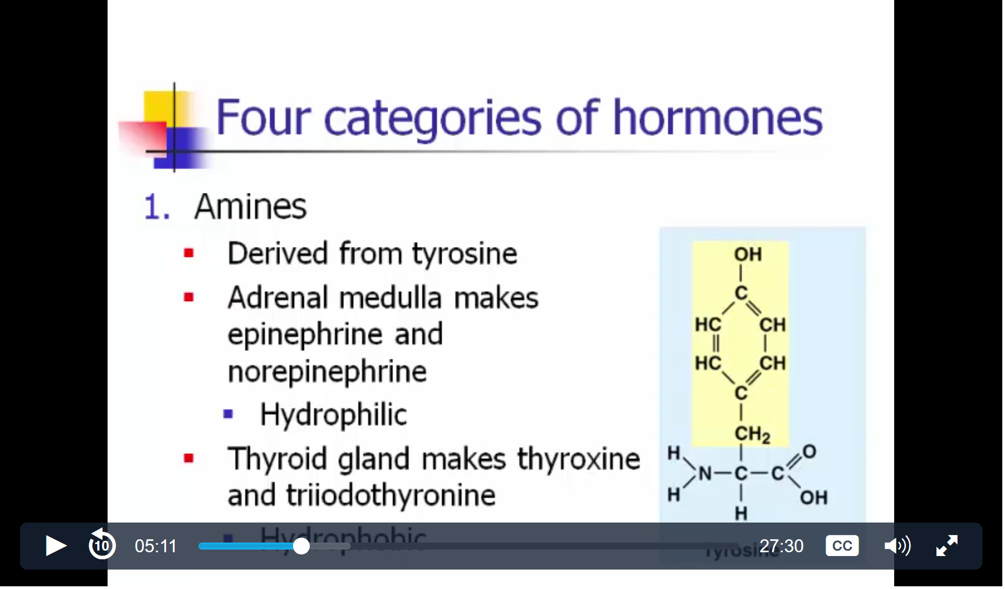 | Four categories of hormones? | Amine, Polypeptide/Protein, Glycoproteins, Steroid (answers had to be taken from another slide too)
 | What are amine hormones derived from? | Tyrosine
 | Tyrosine is used to make what type of hormones? | Amine
 | What types of hormone is epinephrine? | Amine
 | What type of hormone is norepinephrine? | Amine
 | Origin of epinephrine? | Adrenal Medulla
 | Origin of norepinephrine? | Adrenal Medulla
 | Hormones produced by adrenal medulla? | Epinephrine & norepinephrine
 | Epinephrine: hydrophobic/philic? | hydrophilic
 | Norepinephrine: hydrophobic/philic? | hydrophilic
 | What type of hormone is thyroxine? | Amine
 | What type of hormone is triiodothyronine? | Amine
 | Origin of thyroxine? | Thyroid gland
 | Origin of triiodothyronine? | Thyroid gland
 | Thyroid gland produces what hormones | Thyroxine & Triiodothyronine
 | Thyroxine: hydrophobic/philic? | Hydrophobic
 | Triiodothyronine: hydrophobic/philic? | Hydrophobic
 | Amines: hydrophilic/phobic | Both
As you can see, one piece of information from the slide is asked in multiple ways

STEPS SLIDE
Slide | Question/s I Would Write (Each question gets one card) | Answer
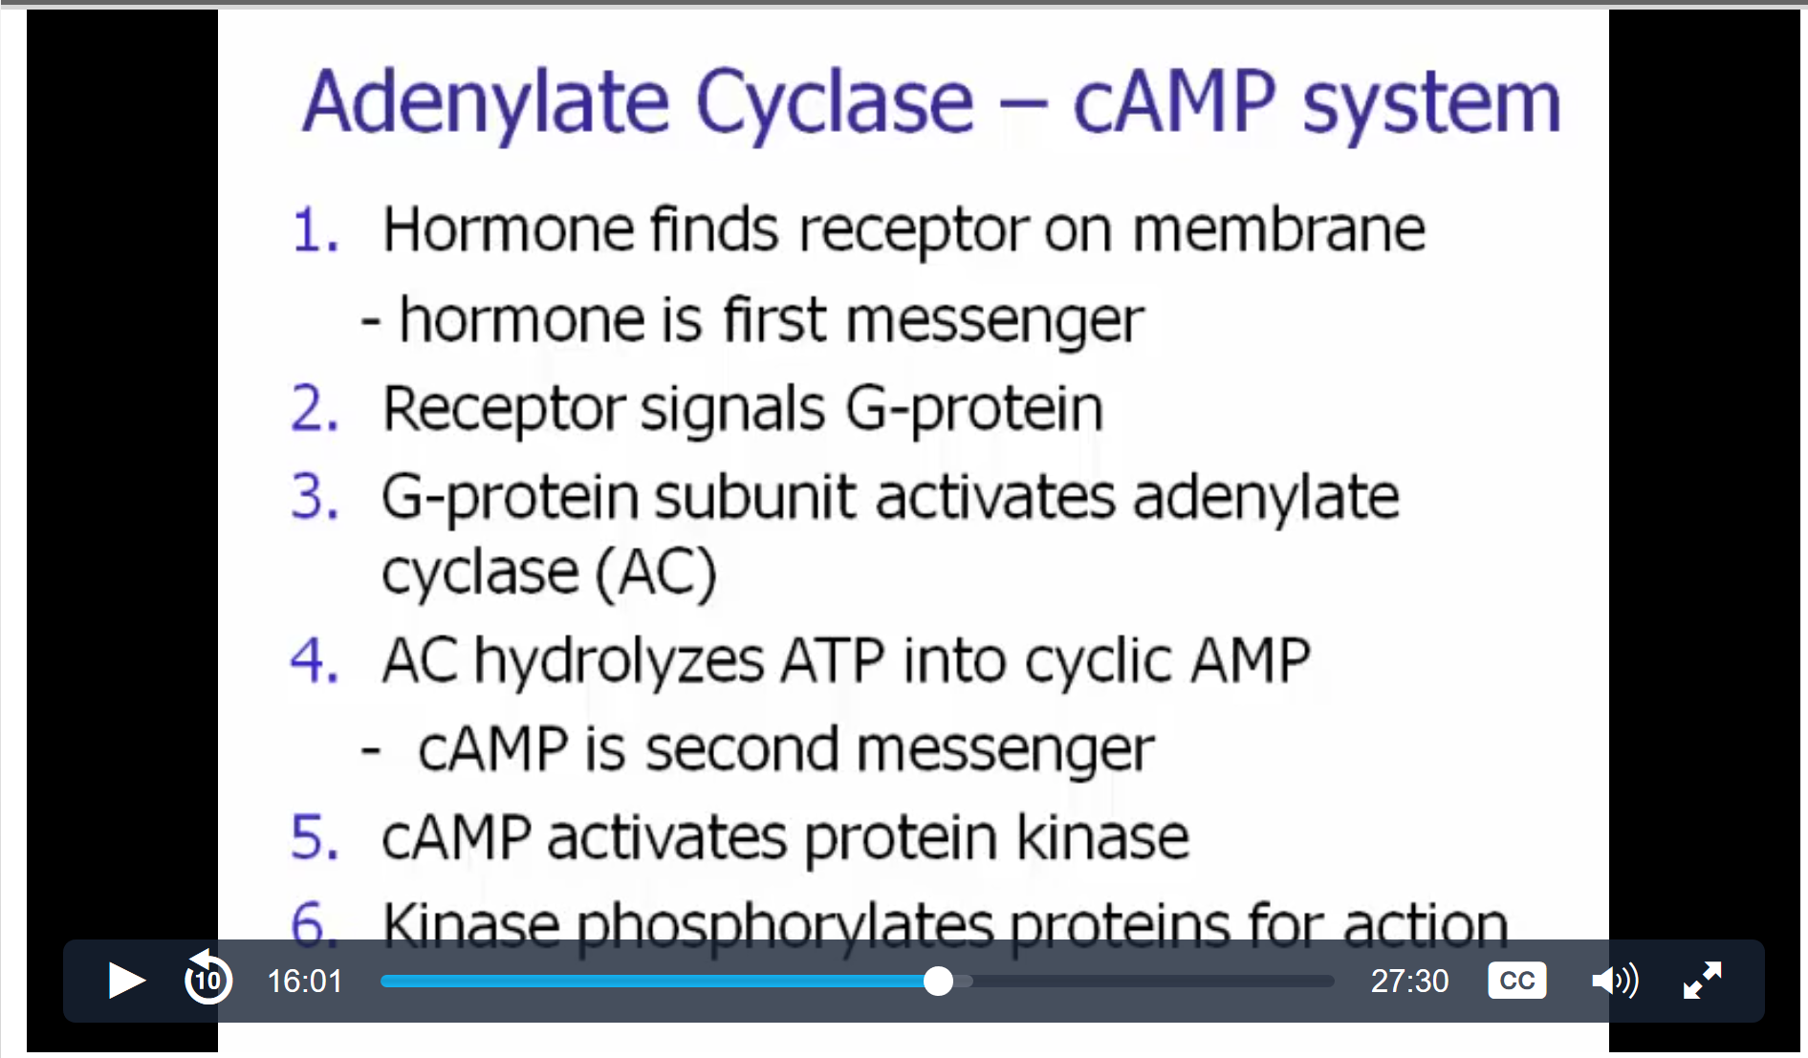 | Write the steps to the Adenylate Cyclase – cAMP system | (the answer side would be blank on the flashcard—if I wanted to check the answer, I would have to look at the slide/my notes)

DRAWING SLIDE
Slide | Question/s I Would Write (Each question gets one card) | Answer
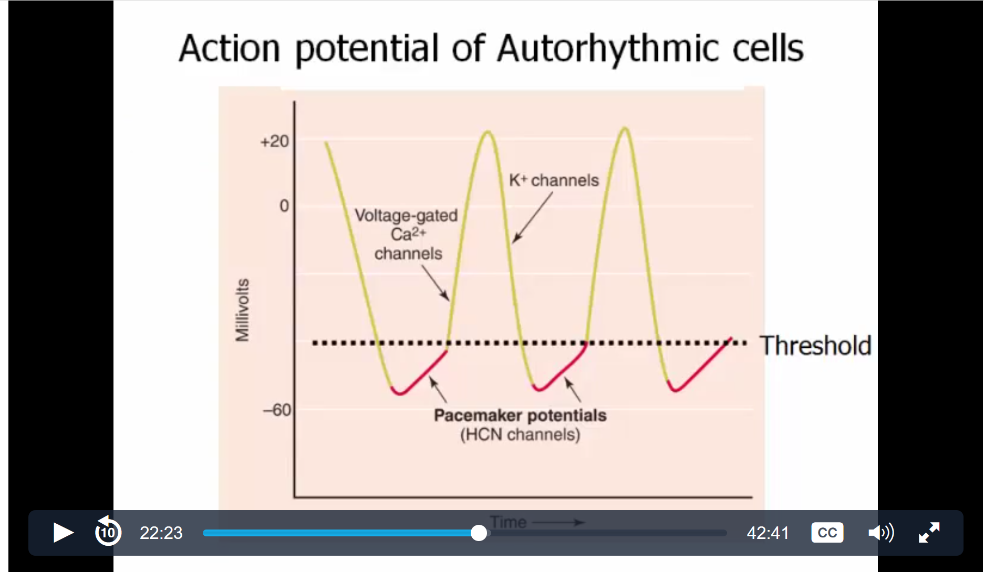 | Draw & label the action potential of autorhythmic cells. | (the answer side would be blank on the flashcard—if I wanted to check the answer, I would have to look at the slide/my notes)

Remembering Steps on Slides
- Please don’t just memorize the steps you see on the slide. You actually have to understand the way things work so that it actually sticks in your brain.
  - For example, I can’t just memorize that calcium is released from the sarcoplasmic reticulum and then actin & myosin attach. I have to know why calcium is released. My thought process is that Ca²⁺ is released because it is the ion that binds to troponin so that the tropomyosin/troponin complex can move aside. That’s important because it frees the myosin binding site so that actin & myosin can bind.
- Everything in physio relates and has a reason why it happens. This is the key to understanding and remembering the information.
  - If you can understand the reasons behind why things happen, you will be able to answer multiple choice questions about the steps.
- Constantly write them steps over and over again.
  - Switch between various processes as you practice to make sure you don’t get steps mixed up between the different processes

Practicing Flashcards
- I don’t just say the answer out loud or in my head. I have to write it out. Some people use whiteboards, but I like writing each answer in a junk notebook. It lets me refer back to what I’ve written before and resembles writing on paper for the test. It doesn’t have to be pretty. My junk notebook is almost illegible.
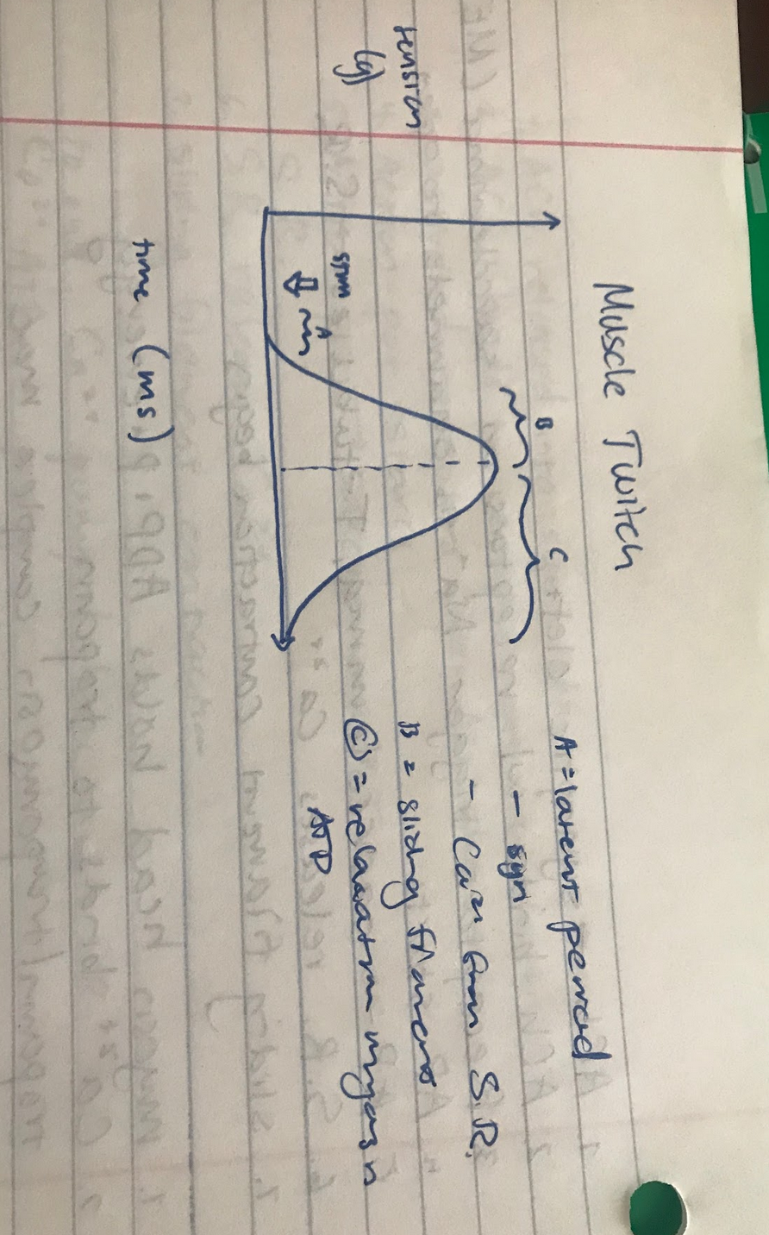
I answered the flashcard asking for a muscle twitch drawing. It is in my junk notebook and very messy but does the job.
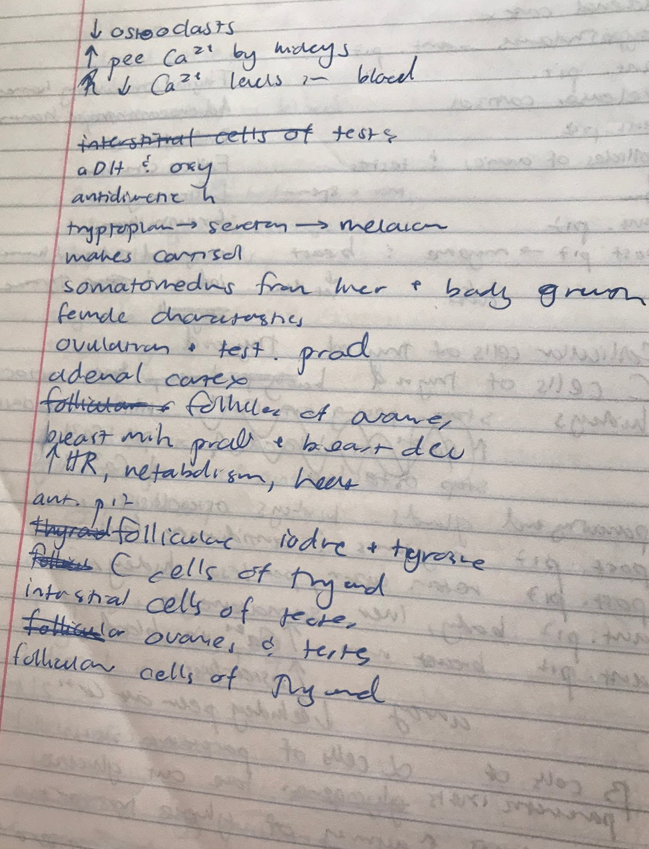
I answered my flashcards asking for all types of information. It is very almost unreadable, but I write down the answer for each question I encounter. It is a good way to practice output
- I make a one stack of notecards per each lecture and keep them separate.
- When you first start studying with these flashcards:
  - Start out with 10 notecards from a lecture’s deck; wrong answers go in one pile; right answers go in another
  - Answer the cards until all 10 are completed
  - Take the wrong pile, shuffle it, and try to answer them correctly so that they can go into the right answers pile; incorrect answers will be put into the wrong answer pile again.
  - Repeat step 3 until all of cards you started with are in the right answers pile
  - Add 10 new cards from the main deck to the cards you just studied
  - Cycle through all the cards until they’re completed (right answers go in one pile; wrong in another)
  - Repeat step 3 until all cards are in the right answer pile.
  - Repeat 5-7 until you are able to go through the whole deck without an issue
  - Repeat with other lecture decks.
- Studying the decks by slowly increasing the increments that you encounter ensures that you aren’t facing too much information all at once. Take it in small bites and slowly add more.
- Repeating the cards ensures that the information is actually sticking.

